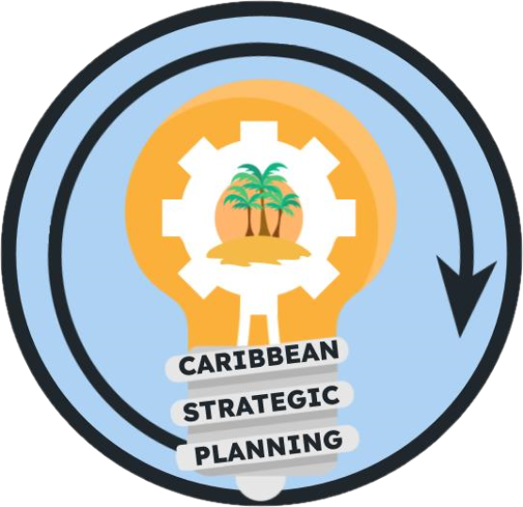Team Charter

Project: Develop habitat/environmental data gap team to develop and prioritize data inventory

**Purpose**

Our purpose is… to identify the groups that are collecting data (available) and then the data that is needed for stock assessment.

Identify and inventory all known available habitat and environmental data sources in the US Caribbean and use the inventory to identify gaps for prioritization of data collections critical to stock assessment improvement

**Goals**

Our goals are…

1. Identify/catalog environmental data (surveys, universities, government) and collect information such as (species, spatial extent, dates, and data category)
2. Identify ongoing efforts that are identifying the parameters that are most useful for stock assessment
3. Synthesize ongoing efforts that are identifying the parameters that are most useful for traditional stock assessment and alternative management methods
   1. Identify who can help to provide this data (possibly: Jason Cope from SSC, Sarah Gaichas from NEFSC)
4. Identify gaps in habitat/environmental data
5. Recommend future actions to continue this work
   1. Coordinate with toolbox group
   2. Add gap identification after other efforts conclude

Our ideal outcomes are… to maintain an inventory of available habitat and environmental data sources and provide a document that recommends specific habitat and environmental data collections that will be beneficial for stock assessment improvement

The deliverables will be…

1. An inventory of available habitat and environmental data sources
2. A list of habitat and environmental data parameters necessary for stock assessment improvement
3. Recommendations for habitat and environmental data collections to fill data gaps in parameters necessary for stock assessment improvement after the ongoing efforts to identify stock assessment parameters are complete
4. A report out to the Caribbean strategic planning team indicating our findings and sharing our deliverables

**Team**

* *Lead*: Liajay Rivera
* *Members*: Nicole Angeli, Graciela Garcia-Moliner, Jennifer Au, Joy Merino, Laughlin Siceloff
* *Stakeholders*: CFMC, CIMAS, DNER/DRNA, DPNR, EBFM TAP, NOAA HQ, NPS, PRSG, QM/CI PSG, SEFSC, SERO, SSC, UPR, USC-A, UVI
* *KSAs*: potential personal to include/ask- Ron Hill, Frank Hernandez, Martha Prada

**Team Process**

* *Meeting day/time*: third Friday of every month, 9-10 AM
* *Meeting frequency*: monthly
* *Decision-making procedures*: Consensus
* *Team communication*: Zoom for standing or any ad-hoc meetings, group emails for routine communications between meetings, and comments in working drafts placed in the team google drive folder.

**Team Norms**

* *Values*:
  + Integrity, reproducibility, transparency, and communication of data
  + Innovation through adaptive management and continuous improvement
  + Respect and trust in data and partnerships
  + Diversity and inclusivity of data sources, data input, communities, and stakeholder ideas
  + Collaboration and cooperation in the collection and dissemination of data
* *Agreements*: The Team agrees to work in an environment of mutual respect where all Team Members will be given an opportunity and encouraged to present ideas and viewpoints. Hand raising will not be needed during Zoom meetings as long as team members do not talk over each other.

**Supporting Resources**

* *Google Drive folder*: [Working Groups](https://drive.google.com/drive/folders/1GR0WWtq_eOGT89s0n8p1imwZ1ntcnczN)
* *Project facilitation*: Rachel Banton (rachel.banton@noaa.gov)
* *Process facilitation*: Richard Maclin, Vivian Matter (vivian.matter@noaa.gov), Jenny Suter (jenny.suter@noaa.gov)

**Metrics**

Success will be measured by a document that prioritizes the habitat/environmental data needs necessary for traditional and alternative management methods